

SPRINT 1
Sprint Backlog & Execution Evidence
SmartGreenAI: Cilantro Crop

Course | Agile Project Management
Project | SmartGreenAI: Cilantro Crop
Student names | Jorge Velez Delgado  Vicente Rocha Alfaro  Oscar Abraham Talavera Nava  Carlos Ramirez Mendoza  Alexis Enrique Valle Parra
Professor | Jorge Rafael Aguilar Cisneros
Sprint | Sprint 1 - 2 weeks
Date | September 17, 2026

1. Project Description
SmartGreenAI: Cilantro Crop is an IoT-driven, cloud-connected precision agriculture system designed to monitor and optimize greenhouse conditions for cilantro cultivation. The solution combines sensor monitoring, role-based platform access, administration functions, cloud-ready data handling, and a dashboard foundation for later alerting, control, and AI capabilities.

2. Sprint 1 Scope
Sprint 1 focuses on establishing the first usable foundation of the platform. The scope includes secure access and role authorization, initial user and administrator management, collection and identification of greenhouse sensor data, and a first dashboard view of current measurements. The sprint also includes the design and validation work needed to demonstrate these functions.
- In scope: US-01, US-02, US-03, US-04, US-05, US-09, US-22, US-23 and US-24.
- Primary deliverables: authentication/access-control design, RBAC permission model and tests, administrator-management prototype and tests, sensor/circuit design and simulation evidence, dashboard prototype, and user/role management design.
- Out of scope for this sprint: cloud transmission APIs, alert generation, actuator/irrigation control, AI recommendations, cross-greenhouse integration, and full system acceptance testing. These remain planned for later sprints.

3. Sprint Goal
Deliver and validate the core access-control, administration, sensor-monitoring, and dashboard foundations required for subsequent SmartGreenAI increments, with each Sprint 1 user story decomposed into actionable tasks and assigned to a team member.

4. Sprint Backlog
ID | User Story / Objective | Priority | SP | Owner | Sprint | Status
US-01 | Authenticate using email/username and password | Must | 3 | Alexis Enrique Valle Parra | 1 | Ready
US-02 | Access only the functions authorized for my role | Must | 3 | Jorge Velez Delgado | 1 | Ready
US-03 | Collect temperature and humidity measurements | Must | 5 | Oscar Abraham Talavera Nava | 1 | Ready
US-04 | Collect soil moisture measurements | Must | 5 | Oscar Abraham Talavera Nava | 1 | Ready
US-05 | Uniquely identify each sensor and associate it with a greenhouse area | Must | 1 | Oscar Abraham Talavera Nava | 1 | Ready
US-09 | See current sensor measurements on a dashboard | Must | 5 | Carlos Ramirez Mendoza | 1 | Ready
US-22 | Manage agricultural users | Should | 5 | Vicente Rocha Alfaro | 1 | Ready
US-23 | Create, modify and manage administrators | Should | 5 | Jorge Velez Delgado | 1 | Ready
US-24 | Manage roles and permissions | Should | 8 | Vicente Rocha Alfaro | 1 | Ready
Sprint 1 total: 9 user stories / 40 story points.

5. User Stories Divided by Task

US-01 - Authenticate using email/username and password
Task ID | Task | Responsible | Status | Evidence / Output
US01-T1 | Design authentication interface and credential fields | Alexis Enrique Valle Parra | Ready | Design / validation artifact
US01-T2 | Define authentication and session-validation logic | Alexis Enrique Valle Parra | Ready | Design / validation artifact
US01-T3 | Design valid/invalid credential test cases | Alexis Enrique Valle Parra | Ready | Design / validation artifact

US-02 - Access only the functions authorized for my role
Task ID | Task | Responsible | Status | Evidence / Output
US02-T1 | Define roles and permissions matrix | Jorge Velez Delgado | Ready | RBAC diagram and test flows
US02-T2 | Design role-based access control (RBAC) | Jorge Velez Delgado | Ready | RBAC diagram and test flows
US02-T3 | Validate authorized and unauthorized access | Jorge Velez Delgado | Ready | RBAC diagram and test flows

US-03 - Collect temperature and humidity measurements
Task ID | Task | Responsible | Status | Evidence / Output
US03-T1 | Select and connect temperature/humidity sensor components | Oscar Abraham Talavera Nava | Ready | Sensor circuit/simulation evidence
US03-T2 | Design measurement-reading flow and sensor interface | Oscar Abraham Talavera Nava | Ready | Sensor circuit/simulation evidence
US03-T3 | Simulate and validate temperature/humidity readings | Oscar Abraham Talavera Nava | Ready | Sensor circuit/simulation evidence

US-04 - Collect soil moisture measurements
Task ID | Task | Responsible | Status | Evidence / Output
US04-T1 | Select and connect soil-moisture sensor components | Oscar Abraham Talavera Nava | Ready | Sensor circuit/simulation evidence
US04-T2 | Design soil-moisture measurement flow | Oscar Abraham Talavera Nava | Ready | Sensor circuit/simulation evidence
US04-T3 | Simulate and validate soil-moisture readings | Oscar Abraham Talavera Nava | Ready | Sensor circuit/simulation evidence

US-05 - Uniquely identify each sensor and associate it with a greenhouse area
Task ID | Task | Responsible | Status | Evidence / Output
US05-T1 | Define unique sensor identifier structure | Oscar Abraham Talavera Nava | Ready | Sensor circuit/simulation evidence
US05-T2 | Define sensor-to-greenhouse-area association | Oscar Abraham Talavera Nava | Ready | Sensor circuit/simulation evidence
US05-T3 | Validate traceability from measurement to sensor/area | Oscar Abraham Talavera Nava | Ready | Sensor circuit/simulation evidence

US-09 - See current sensor measurements on a dashboard
Task ID | Task | Responsible | Status | Evidence / Output
US09-T1 | Design dashboard layout for current measurements | Carlos Ramirez Mendoza | Ready | Dashboard prototype images
US09-T2 | Create dashboard prototype for sensor cards/values | Carlos Ramirez Mendoza | Ready | Dashboard prototype images
US09-T3 | Validate latest-measurement display and readability | Carlos Ramirez Mendoza | Ready | Dashboard prototype images

US-22 - Manage agricultural users
Task ID | Task | Responsible | Status | Evidence / Output
US22-T1 | Design agricultural-user management interface | Vicente Rocha Alfaro | Ready | Design / validation artifact
US22-T2 | Define create/update/activate/deactivate user logic | Vicente Rocha Alfaro | Ready | Design / validation artifact
US22-T3 | Design user-management validation and access tests | Vicente Rocha Alfaro | Ready | Design / validation artifact

US-23 - Create, modify and manage administrators
Task ID | Task | Responsible | Status | Evidence / Output
US23-T1 | Design the administrator management interface | Jorge Velez Delgado | Ready | Admin prototype, management diagram and test flows
US23-T2 | Design administrator CRUD logic and validations | Jorge Velez Delgado | Ready | Admin prototype, management diagram and test flows
US23-T3 | Validate functionality and restrict access | Jorge Velez Delgado | Ready | Admin prototype, management diagram and test flows

US-24 - Manage roles and permissions
Task ID | Task | Responsible | Status | Evidence / Output
US24-T1 | Define role and permission data model | Vicente Rocha Alfaro | Ready | Design / validation artifact
US24-T2 | Design role/permission management interface and logic | Vicente Rocha Alfaro | Ready | Design / validation artifact
US24-T3 | Validate permission changes and restricted access | Vicente Rocha Alfaro | Ready | Design / validation artifact

6. Acceptance Criteria for Sprint 1
User Story | Acceptance Criteria
US-01 | Valid credentials grant access; invalid credentials are rejected.
US-02 | Each role can access only its authorized functions and data.
US-03 | Temperature and humidity measurements are captured and available to the system.
US-04 | Soil moisture measurements are captured and available for irrigation decisions.
US-05 | Each sensor has a unique identifier and is linked to a greenhouse area.
US-09 | The dashboard displays the latest available sensor measurements.
US-22 | An administrator can create and manage agricultural user accounts.
US-23 | A super administrator can create, modify, and manage administrator accounts.
US-24 | A super administrator can create and manage roles and permissions.

7. Sprint 1 Evidence

US-01 Login Screen Validation
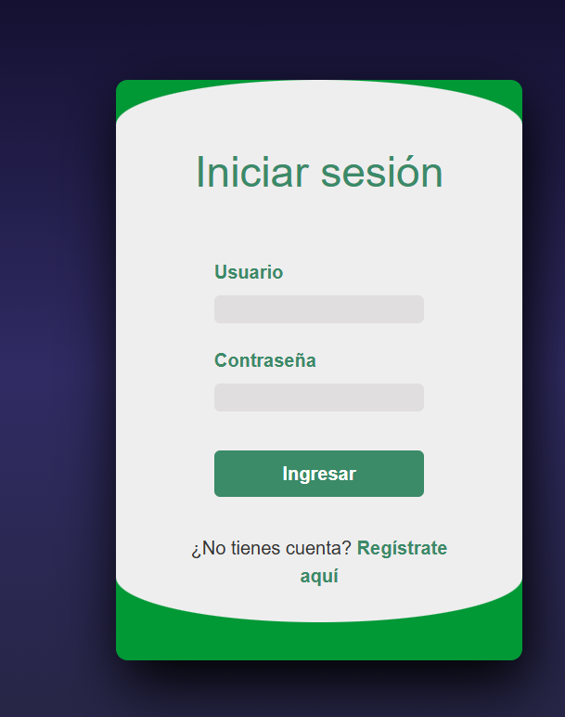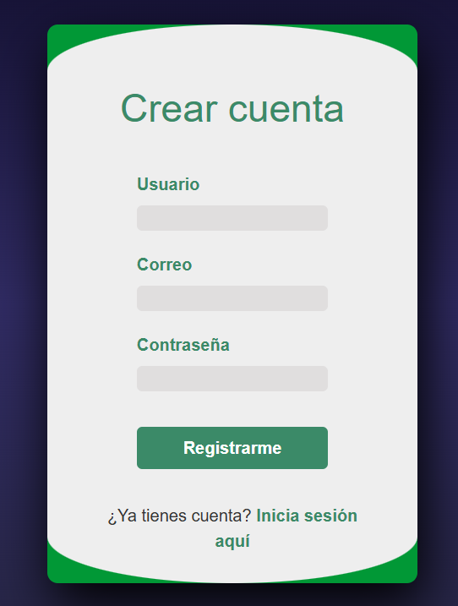

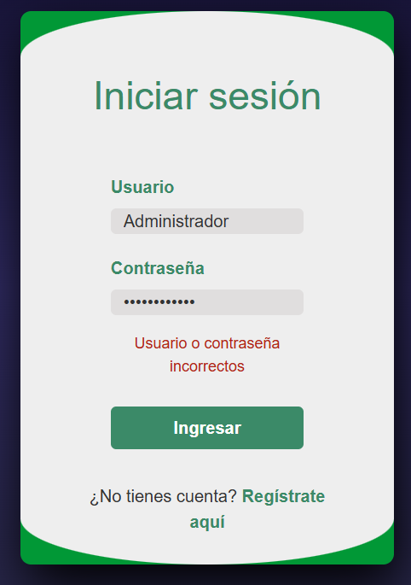

US-02 - RBAC Diagram
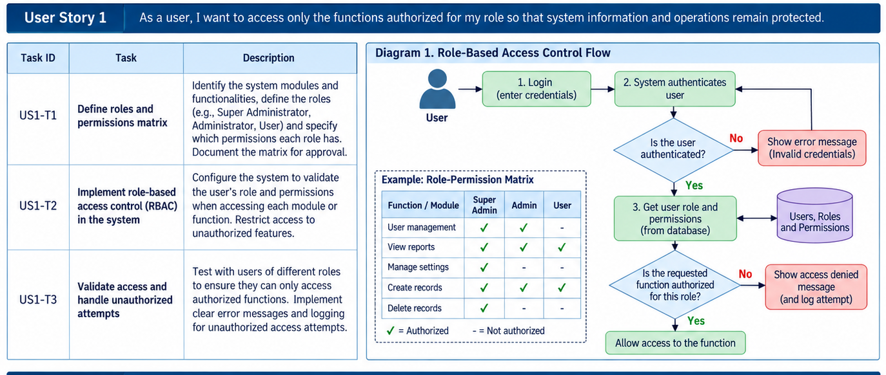
Figure - US-02 - RBAC Diagram

US-23 - Administrator Management Diagram
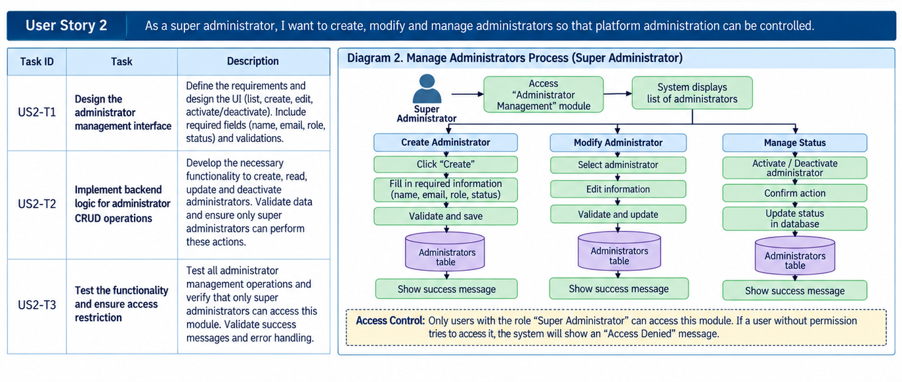
Figure - US-23 - Administrator Management Diagram

US-09 - Dashboard Evidence 1
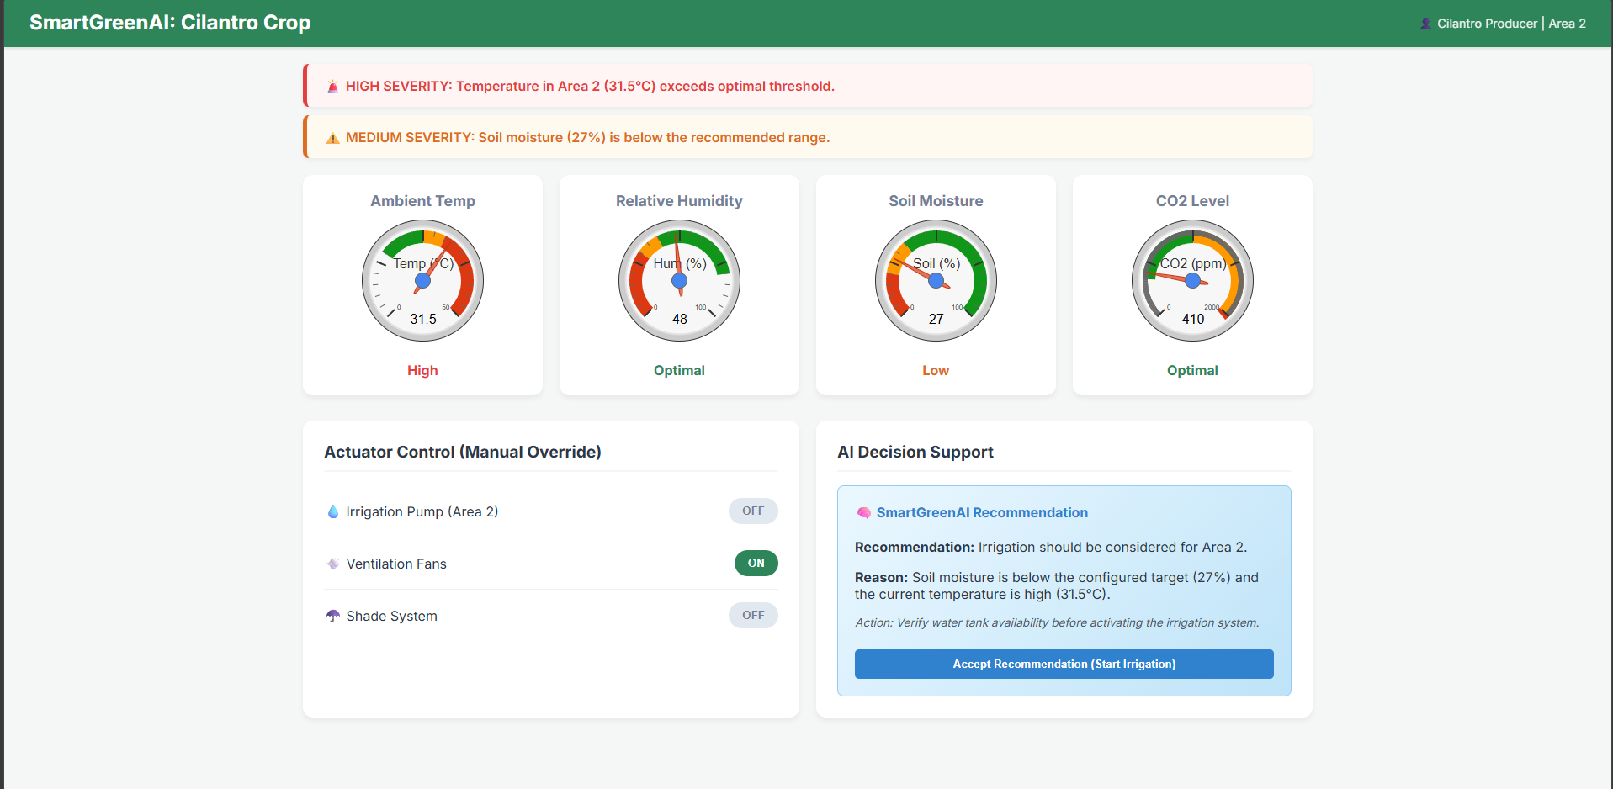
Figure - US-09 - Dashboard Evidence 1

US-09 - Dashboard Evidence 2
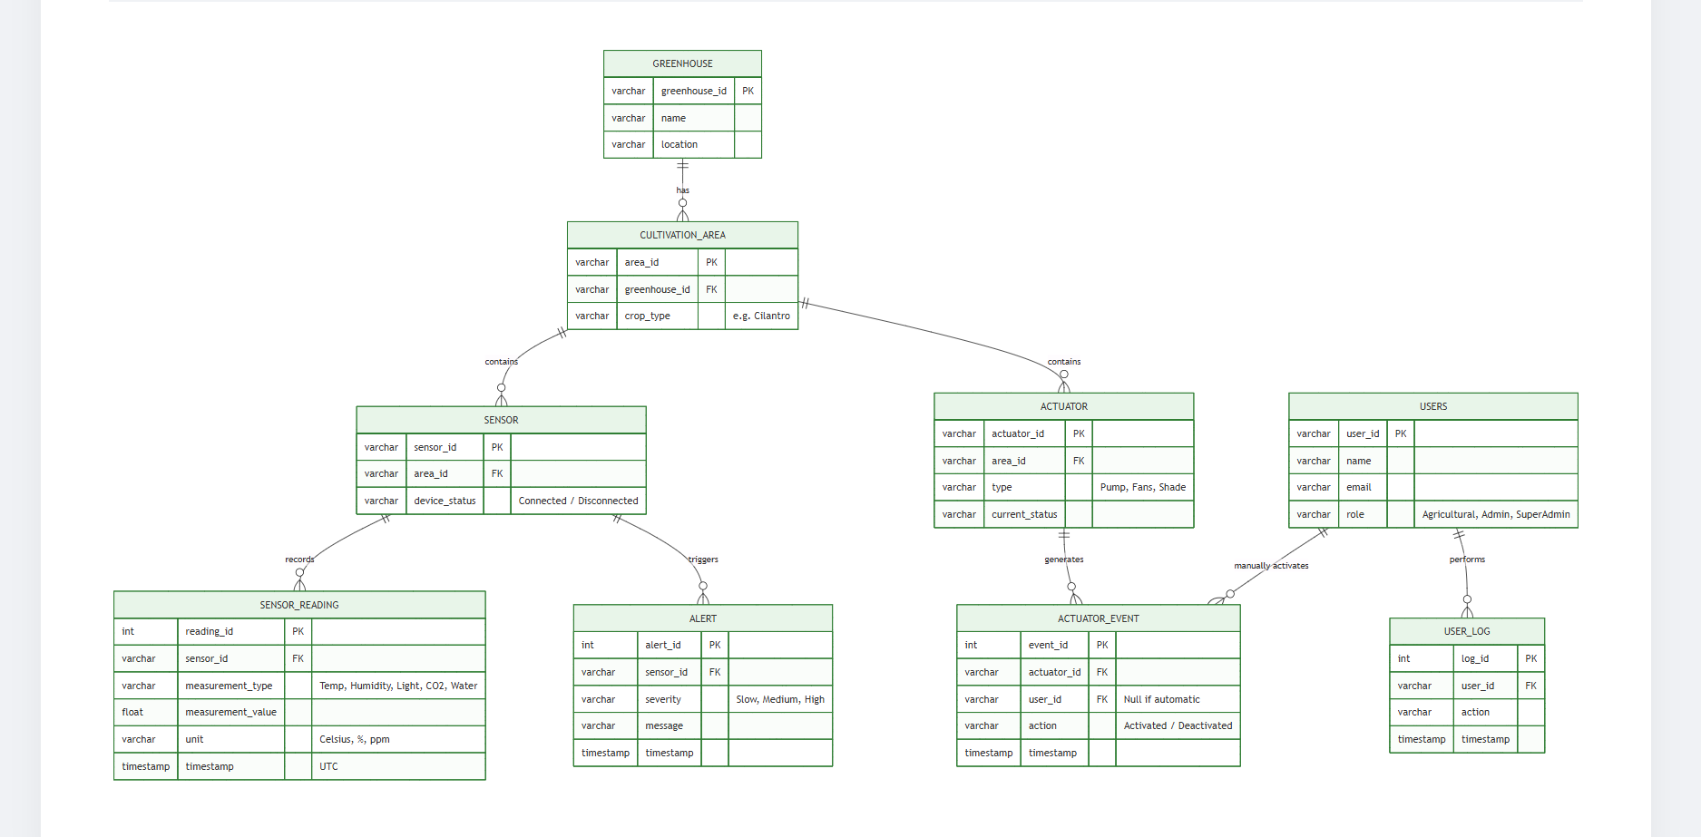
Figure - US-09 - Dashboard Evidence 2

Sensor Simulation Evidence
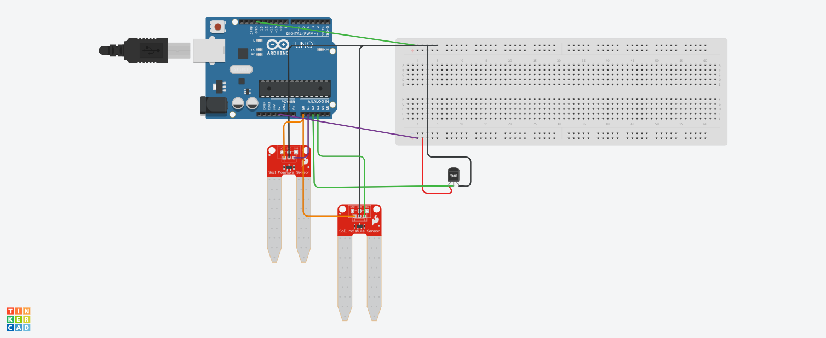
Figure - Sensor Simulation Evidence

8. Sprint 1 Review Summary
Sprint 1 documentation now explicitly includes the sprint scope, a dedicated Sprint Backlog, decomposition of every Sprint 1 user story into tasks, and a meeting record with evidence. All Sprint 1 user stories and tasks are shown with status Ready, as requested for the dashboard-aligned submission. The evidence package also contains prototypes, diagrams, simulations, and test-flow material supporting the sprint work.

9. Scrum Roles
Student | Role
Jorge Velez Delgado | Scrum Master
Vicente Rocha Alfaro | Developer
Oscar Abraham Talavera Nava | Developer
Carlos Ramirez Mendoza | Developer
Alexis Enrique Valle Parra | Product Owner

